Annual Meeting of the LGA General Assembly
30 June 2015
LGA consolidated financial statements for the year to 31 March 2015
Purpose of the Report

To invite the General Assembly to receive the LGA consolidated financial statements for 2014/15.

The LGA’s consolidated financial statements for the year ended 31 March 2015 are included in the LGA Annual Report, enclosed with this agenda. They were reviewed by the Audit Committee on 3 June and approved by the LGA Leadership Board on 10 June. They are expected to receive an unqualified audit opinion from the external auditors PKF Littlejohn LLP. The auditors will sign the consolidated accounts once the financial statements for the individual companies feeding into the consolidated accounts have been adopted at their respective board meetings in June 2015.

The financial statements show a consolidated surplus of £7.626 million before financing incoming costs, contributions from joint ventures, proceeds from the sale of shares and adjustments relating to additional pension contributions. The overall pension deficit increased by £20.923 million to £112.860 million. This valuation has been carried out in line with FRS17 accounting standards and is therefore subject to market performance on a specific date.

The LGA is making additional pension contributions in order to eliminate the deficit over a period of between 15 and 22 years. The attached briefing note summarises the movements between the Pension Fund Balances for the LGA and IDEA since the last Triennial valuation at March 2013, together with the key reasons for the increase in net liabilities shown in the 2014/15 Financial Accounts. In addition the note summarises the key actions being taken to reduce the overall level of deficit.

Recommendation

That the General Assembly receives the financial statements for the year to 31 March 2015.

Contact officer: | Stephen Hughes
Position: | Executive Director
Phone no: | 020 7664 3109
E-mail: | stephen.hughes@local.gov.uk

Annual Meeting of the LGA General Assembly
30 June 2015
Briefing Note – LGA / IDEA Pensions update June 2015
Purpose

- This note summarises the movements between the Pension Fund Balances for the LGA and IDEA since the last Triennial valuation at March 2013, together with the key reasons for the increase in net liabilities shown in the 2014/15 Financial Accounts. In addition the note summarises the key actions being taken to reduce the overall level of deficit.

Current Position

- The table below presents the key values as contained in the Accounts for the Financial Years 2012/13 to 2014/15.
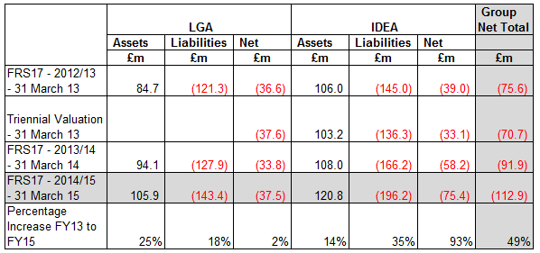

- The main cause of the increase over the last 2 years has been the fall in the discount rate based on the return corporate bonds (4.5% to 3.1%). This has been offset by lower assumptions for the inflation on pensions. For the LGA this has also been offset in the current year by early payment of the deficit contributions to the Merseyside Pension Fund (£1.9m) and the combination the West Sussex and Merseyside Pension Funds (£10.0m)
Plans to cover the deficit

- The LGA and IDEA are currently making additional contributions averaging over £4 million per annum. Actuarial advice indicates that on reasonable long term assumptions, these contributions will be sufficient to eliminate the deficit over a period of 22 years for the LGA and 15 years for the IDeA. In addition the LGA’s Leadership Board has commissioned further work to investigate ways in which the management of the pension deficit can be improved and has agreed to the refurbishment of Layden House from 2016 as part of this strategy.

